# **Yrysbaev Maksatbek**

Professor’s Name: Glory Kurian

Course Name: COMP 2415 Systems Programming

Date: 05.07.2024

# Assignment 4

1. Write out the memory map for the following code, providing all values at the end of execution. What is the exact output produced by this program?

#include <stdio.h>

int x;

int Magic(int z)

{

z=x*3;

return(z);

}

int main()

{

int y;

x=4;

y=6;

x=Magic(y);

printf("%d %d\n)

}

Memory Map:

x: Global integer variable

y: Local integer variable in main

z: Local integer variable in Magic

Values at the End of Execution:

Initially, x = 4 and y = 6.

When Magic(y) is called, z takes the value of x * 3, so z = 12.

Magic(y) returns 12, and x is updated to 12.

y remains unchanged at 6.

Consider the following program:

#include <stdio.h>

main()

{

int a,b,c,d;

a=0;

while (1) {

printf("%d\n",a);

printf("Input? ");

scanf("%d",&c);

if (c == 0) break;

d=0;

for (b=1; b<=c; b++)

if (c%b == 0) d++;

if (d == 2 || c == 1) a=a+c;

}

}

What does this program do? Rewrite the code, organizing it using sound principles. Include

comments and redo variable names and indentation. Use multiple functions, blocks, and/or

preprocessing if you deem it necessary.

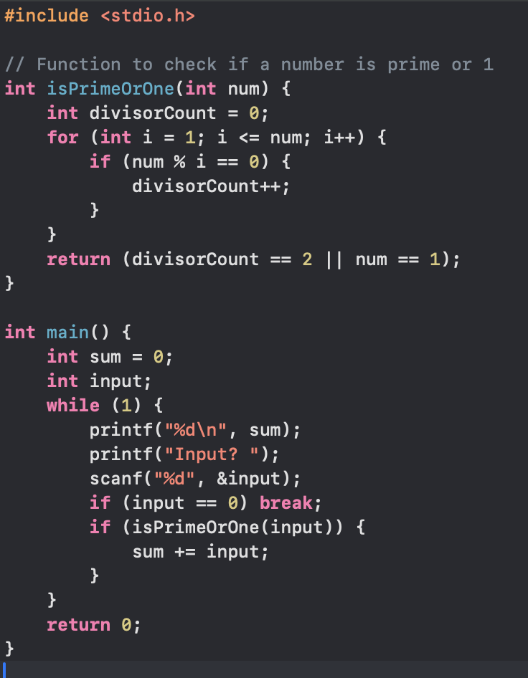

The program continuously accepts an integer input from the user, checks if the number is a prime number or 1, and adds it to a cumulative sum. It prints this sum after each input. The loop terminates if the user inputs 0.